FYI………………………..

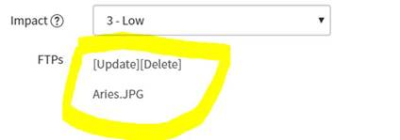

function onLoad() {

   //Type appropriate comment here, and begin script below

   var presentAdiAttachment = false;

   try{

                             var vals = top.document.body.innerHTML;

                 //alert(vals);

                 var txt = vals.split('<a class="attachment" href="sys_attachment.do?');

                // alert(txt.length);

                if (txt.length > 2)

                               {

                                             presentAdiAttachment = true;

                               }

   }catch(e)

                 {

                               presentAdiAttachment = false;

                 }

              if (presentAdiAttachment == true)

                             {

                                           alert('Attachment is Present!!');

                                          // Attachement is present, you may add your code logic e.g. return true;

                             }

              if (presentAdiAttachment == false)

                             {

                                           alert('Attachment is NOT Present!!');

                                           // Attachement is present, you may add your code logic e.g. return false;

                             }

}

Thanks,

Gyan